Game levels design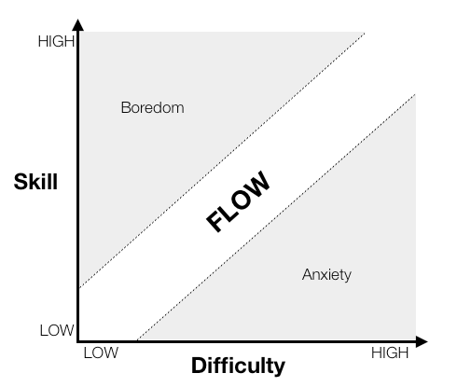

*(Mimic Plants vs. Zombies?)*

Start of very easy:

* Enemies match gun, one enemy at a time.
* Lasts about 30 seconds
* Gets player confident and satisfied.

First level:

* Introduce bullet mismatch, force the player to either shoot away randomly or at the wrong enemy to experience effects.
* Introduce two enemies at one time.

Quick break:

* Give player a few seconds to recuperate
* One or two enemies within 15 seconds

Second level (first wave):

* Gradually introduce a light wave (3 enemies max on the screen at one time)

Quick break:

* Indicate end of wave
* Introduce bomb

Third level (second wave):

* Slightly more intense wave (4 enemies on the screen)
* Can use bomb

Quick break

Fourth level:

* Repeat level 3

Score:

Number of enemies hit

Survival time (bonus?)

Things to introduce in next prototypes:

Bomb

* Allows player to kill more than one thing at a time.
* Does a lot of damage to a group of enemies.

Camera rotation

* Adds difficulty